1. In what context was the photelectric effect discovered and why was this discovery somewhat paradoxical?

2. What is a diode, a photodiode and dark current of a diode?

3. Figures 2 & 3 in the PASCO lab instruction manuals have errors in its labeling of the plots. What are these errors and correct by properly labeling the plots.

4. Why do you think it is important to let apparatus warmup for 10 minutes before making measurements? Hint: Heat and calibration.

5. The PASCO instruction manual has an error on page 15 where it defines % difference as

$percent difference= \left|\frac{h-h_{0}}{h_{0}}\right|*100$. What should this be correctly called and why?

6. Below you will find a spectrum for mercury vapor. Label the frequencies and color of the filters used in this experiment.

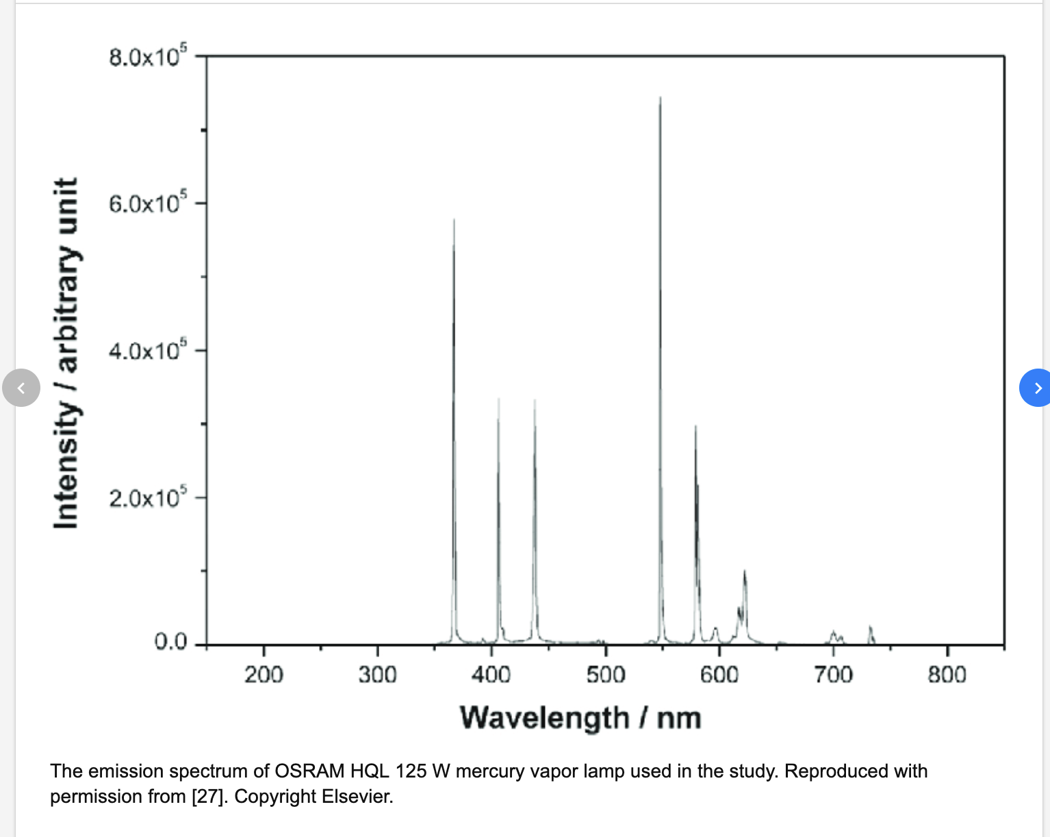

7. In Appendix A: Specifications of PASCO instructions its states that the (voltage and current amplifier displays) have “ 3-1/2 or 4-1/2 Digit display”. What does this mean?

8. In class Dr. Ostrovskii stated that no Nobel prizes have been awarded purely for theoretical work in physics. While this is true, you will find that in the reasons given for the Nobel prizes; there have been prizes given for theoretical work. An example of this can be seen by the reasons given for both Einstein in 1922 and in particular for the 1933 prizes given to

Erwin Schrödinger and Paul Adrien Maurice Dirac “for the discovery of new productive forms of atomic theory”

Go to the Nobel prize website below and comment on this fact.

https://www.nobelprize.org/prizes/lists/all-nobel-prizes-in-physics/

